FINAL ANNOUNCEMENT
5thSEANACConference, 9th–13thJune,2014, ReefHotel,MombasaKenya

THEME: “From Wet Chemistry to Nano-Chemistry”-The Role of Analytical Chemistry in Building Vibrant Economies, Industries, Food Security and Environmental Management

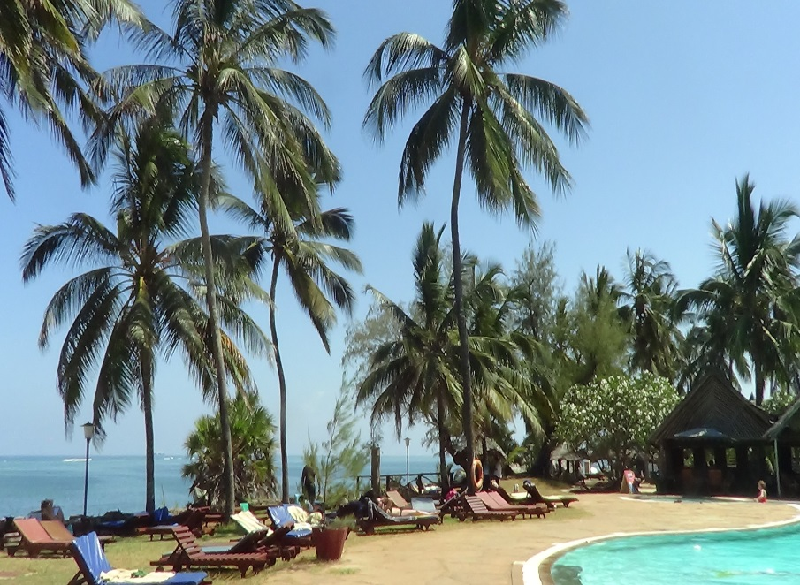 | 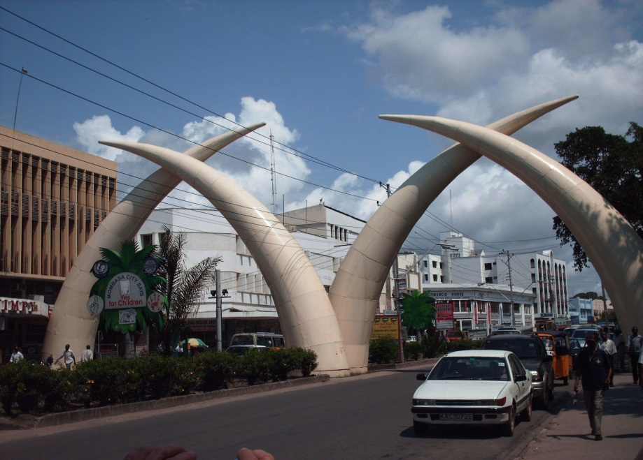
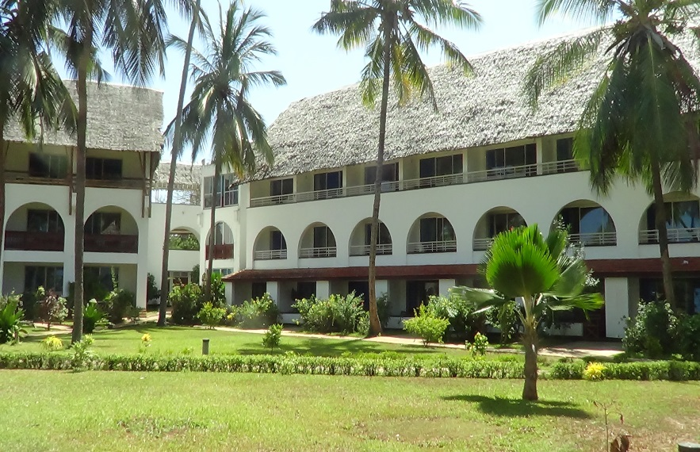 | 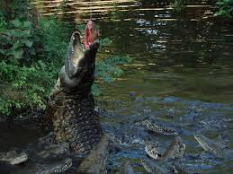

Preamble
SEANAC was established in 2002 with members drawn from Botswana, Swaziland, Mozambique, Lesotho, Zimbabwe, Zambia, Malawi, Tanzania, Uganda and Kenya, during a workshop held in Gaborone, Botswana and funded by Swedish International Development Cooperation Agency (SIDA). SEANAC objective is to promote analytical chemistry in the region through collaboration, research, training, and information sharing.
The objective of the current conference is to scientists in Academia with Government Departments, Industries, entrepreneurs and policymakers.

2. CallforPapers
SEANAC is organizing a five days Conference to discuss advances in broad areas of analytical Chemistry from Wet Chemistry to nanochemistry in building sustainable economies, industry, food security and environmental management. The Conference is jointly organized by International SEANAC Secretariat and the University of Nairobi (local Secretariat). We are pleased to invite you to this Conference that will be held from the 9th to 13th June, 2014 in Mombasa, Kenya.
3. The conference will cover the following thematic areas:
Accreditation, Quality control and Quality assurance | Instrumental Methods of analysis
Mining and petroleum industry | Biosensors and biomakers
Pesticides and fertilizers | Pharmaceutical Chemistry
Nano chemistry/ Nano technology | Clinical Medicine and health applications
Environmental Pollution and Monitoring | Food science and food technologies

4. Importantdates:
Deadline for submission of abstracts 10thMay 2014 Registration deadline 30thMay,2014 Notification of acceptance of abstracts 15thMay 2014 Submission of full papers 22nd May2014
5. The invited keynote speakers will include:
Prof N. Bashir Sudan | Prof. N Zaranyika Zimbabwe
Prof. M. Mohammedan Sudan | Prof. S. Wandiga Kenya
Prof. N. Torto Botwana | Pror. I.Iwuoha Nigeria
Prof. M. Nindi Zimbabwe | Prof. M. Sekota Lesotho
Prof. C. Ngila South Africa | Prof. N. Megersa Ethiopia
Prof. S. Jonnalaganda South Africa | Prof. J. Mbindyo USA
Dr. N. Pacini Italy | Prof. A Mugweru USA
Dr. A.Mmochi Tanzania | Dr. I Mwangi Kenya
Prof. S. Mbogo Tanzania | Dr. G. Njoroge U.S.A.
Prof. E. Kiremire Namibia | Prof. G. Kamau Kenya

6. Submission
The SEANAC Secretariat welcomes papers, which demonstrate practical applications, real world situations and problem solving. Presentations are for 20 minutes and plenary papers 30 minutes. Key note speakers will take 50 minutes.
The manuscript of submitted papers should be written in English and include the following information: title of the paper; author/co-authors’ name(s) and affiliation(s); abstract, introduction, rationale and objective(s) of the work, experimental, conclusions and references. Please send an abstract of 300 words, based on a theme outlined above to: Dr.Peterson Guto (peterson.guto@uonbi.ac.ke) and/or Prof. Geoffrey Kamau (gnkamau@uonbi.ac.ke)

7. Conference Venue
Reef Hotel, Mombasa,Kenya http://reefhotelkenya.com/
8. Conference registration fee:
Participants:(International): US$300.00
:(Local): US$ 200.00
Students : US$ 180.00
Preconference Registration fee: US$ 60.00

9. Exhibitors
Companies or organizations, which are interested in exhibiting their materials or in holding vendor demonstrations, are invited. Registration fee for exhibition is US$400.00

10. Travelling to Mombasa, Kenya
Mombasa, Kenya can be reached by air (Moi International airport) or by road. Conference participants should contact the secretariat for more details. You are advised to make your travel arrangements early as this will be approaching the tourist high season and flight bookings may be difficult to get

11. Contactdetails
For additional details, visit the conference web site at http://www.seanac.org and/or http://www.uonbi.ac.ke

11. International Advisory Committee | 12.Local Organizing Committee
Prof. Nelson Torto, SEANAC Secretary General & CEO Prof. M.M. Nindi, SEANAC  Prof. J.C Ngila, SEANAC  Prof.G. Kamau (Kenya), SEANAC  Dr S. Dube (Zimbabwe), SEANAC Dr.V.Obuseng, (Botswana), SEANAC  Dr. H. Okatch, SEANAC  Dr. T. Wondimu, Ethiopia  Dr.M. J Mavura, Tanzania  Dr.Matoetoe, Lesotho  Dr. W.R. L.Masamba, Malawi  Dr. Carlosda Maia, Mozambique  Dr. S. S.Mamba,Swaziland  Dr. F. N. Ngasappa, Tanzania  Prof. S. Nyanzi, Uganda  Dr. K. Sichilongo, Zambia  Dr. Sithole, Zimbabwe  Prof.M.F. Zaranyika, Zimbabwe, Prof.S. Mbogo, Tanzania  Dr. W.R.L. Masamaba | Prof. G.N. Kamau, University of Nairobi, Kenya, Chairman  Dr. P.M. Guto,University of Nairobi, Kenya, Secretary  Dr. Joseph Mwaniki, University of Nairobi, Kenya, Deputy Secretary and Advertisement Officer  Dr. Immaculate Michira, University of Nairobi, Kenya, Treasurer  Dr. Vincent Madadi, University of Nairobi, Kenya, Program Officer  Dr. Deborah Abongo, University of Nairobi, Kenya, Deputy Advert Officer  Dr.H. Nyambaka, Kenyatta University, Kenya  Prof. S.M. Kagwanja, Chuka University, Kenya  Dr. J.M. Wanjohi, University of Nairobi, Kenya, Public Relations Officer  David Koech, Kenya Bureau of Standards, Kenya  Dr. Solomon Derese, University of Nairobi, Website Manager  Dr. Albert J. Ndakala, member  Prof. David N. Kariuki, member  Dr. Amir Yusuf, University of Nairobi, Host  Mr. Charles Mirikau, University of Nairobi, Kenya,  Travel and logistics

13. Excursions:

Excursion visits to some of the world famous tourist attractions such as Fort Jesus, Marine Park, Haller Park and Gedi ruins. Others sites are being planned. Excursions will be at an extra cost.

Fort Jesus- You will see a Portuguese fort built in 1591 by order of King Philip I of Portugal, then ruler of the joint Portuguese and Spanish Kingdoms, located on Mombasa Island to guard the Old Port of Mombasa. | Marine Park-comprises of the sea waters, mangroves, sea grasses, and sea weeds. It is home to variety of marine life e.g. Crabs, Sea urchins, Sea cucumbers, Sea Stars/ Starfish, Sea Jellies. | - Haller Park- A nature park in Bamburi, Mombasa, on the Kenyan Coast. It is the transformation of a quarry wasteland into an ecological paradise. | Gedi ruins- You will see the remains of a Swahili town located in Gedi, a village near the coastal town of Malindi in Kenya.
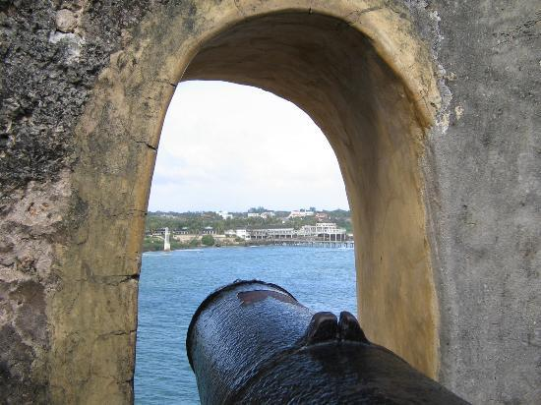 | 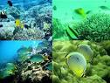 | 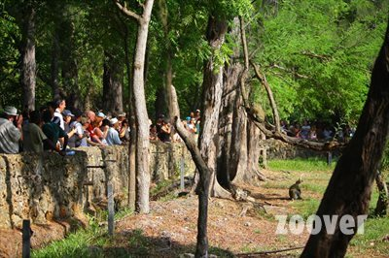 | 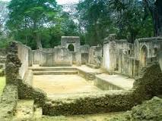

TERMSANDCONDITIONS
Conference registration fees will cover meals,refreshments,stationaryandconferencefacilities. accommodation costs are NOT included.
CONTACT
Dr.Peterson M.Guto
DepartmentofChemistry,UniversityofNairobi,Box30197,00100
Nairobi,Kenya
E-mail:seanac.kenya@uonbi.ac.ke and peterson.guto@uonbi.ac.ke
Copy to: gnkamau@uonbi.ac.ke
andakala@uonbi.ac.ke

